**11.LINEAR REGRESSION**

**NAME : ENIYA.B.A**

**CLASS: CSE-B**

**ROLL NO : 230701085**

import numpy as np

import pandas as pd

df=pd.read_csv('Salary_data.csv')

df.info()

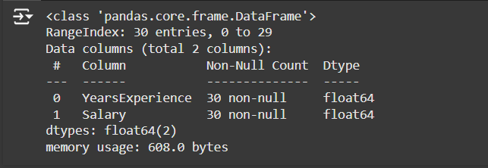

df.dropna(inplace=True)

df.info()

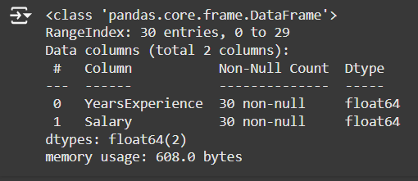

df.describe()

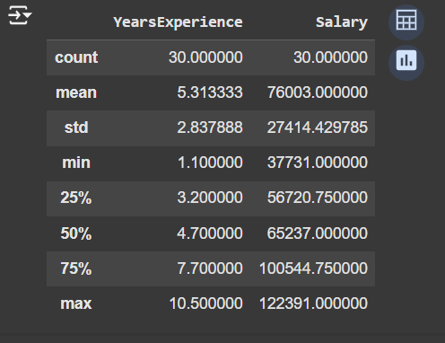

features=df.iloc[:,[0]].values

label=df.iloc[:,[1]].values

from sklearn.model_selection import train_test_split

# Assuming `features` and `label` are already defined in your code

x_train, x_test, y_train, y_test = train_test_split(features, label, test_size=0.2, random_state=42)

from sklearn.linear_model import LinearRegression

model=LinearRegression()

model.fit(x_train,y_train)

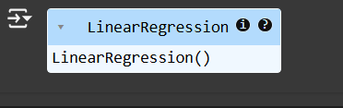

model.score(x_train,y_train)



model.score(x_test,y_test)



model.coef_



import pickle

pickle.dump(model,open('SalaryPred.model','wb'))

model=pickle.load(open('SalaryPred.model','rb'))

yr_of_exp=float(input("Enter Years of Experience: "))

yr_of_exp_NP=np.array([[yr_of_exp]])

Salary=model.predict(yr_of_exp_NP)



print("Estimated Salary for {} years of experience is {}: " .format(yr_of_exp,Salary))

